Table of Contents
Steps: 2
1. Architecture of DevSecOps CI/CD project 2
2. Creating VPC and it’s component 3
3. Configure instances 4
4. Configure instance for k8s cluster in private subnet 7
5. Jenkins CI/CD 7
5.1 Integrating k8s as Jenkins Node. 7
5.2 Integrating Docker with Jenkins 9
5.3 Integrating jenkins sonarqube 10
6. CI/CD pipeline 11
7. Create target group and Load balancer. 14
8. Configure ASG. 18

Steps:

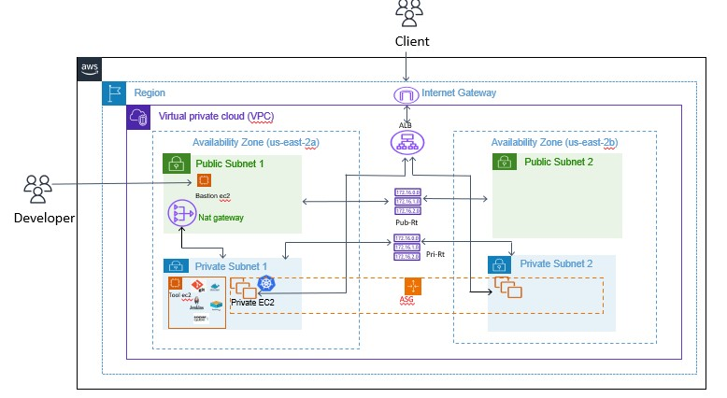
Architecture of DevSecOps CI/CD project

FIG 1
- Created VPC for application security scalability and availability.
- Hosted Public subnet and private subnet in two availability Zone
- In public subnet created a bastion host
- Private instance is created in private subnet in which Git, Docker, SonarQube and Trivy configured via bastion host
- In private subnet Kubernetes cluster is configured.
- Deploy the application on Private instance node using Kubernetes.
- ASG will scale the instances based on defined policies and makes application highly available.
- Load balancer distributes load evenly
- End user can access the application using load balancer URL

Creating VPC and it’s component
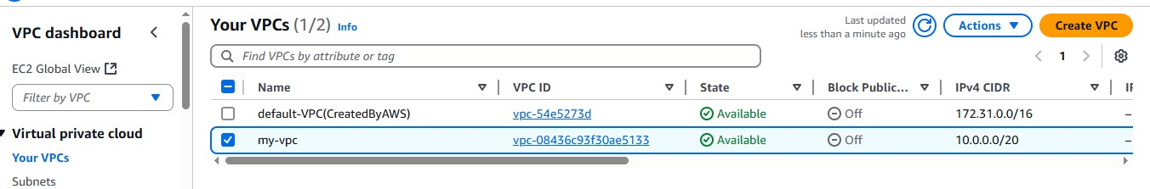

FIG 2
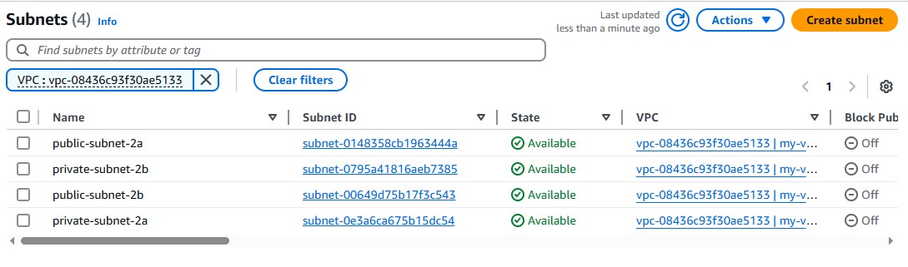
Creating public and private subnets in two AZ (us-east-2a and us-east-2b)

FIG 3
Create Internet- gateway and attach it to VPC
my-IGactionsattchchoose my-vpc
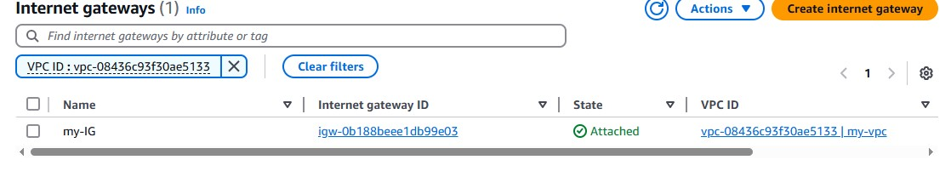
c

FIG 4
Creating public and private Route Table, and associate respective subnets with it.
public-RTsubnet associationschoose all public subnetsassociate.
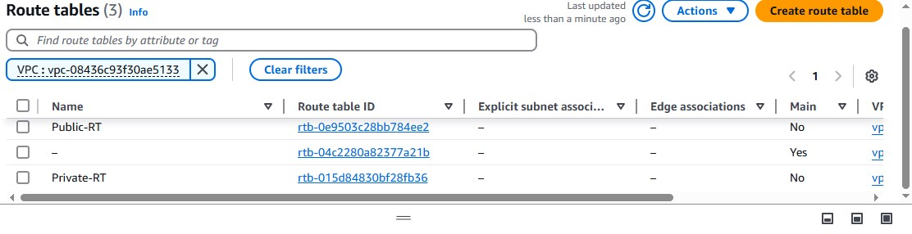
Same for private-Rt and attach private subnet

Create a NAT gateway in public subnet and attach it to private subnet.
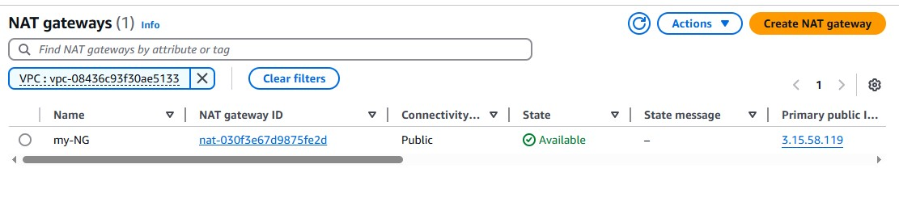
private-RTroutes and my-NGg

FIG 6

Configure instances
Create two instances in public subnet, one with Public-Ip (bastion ec2) and another without Public-IP.
Jump server ( Bastion host with public-Ip)
Tool-server (without public-Ip) only to install tools like Jenkins, Docker, SonarQube and Trivy image-scanner
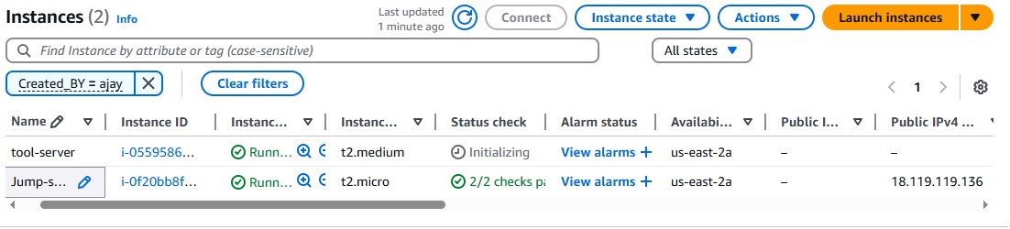

FIG 7
Login to tool-server via Jump-server.
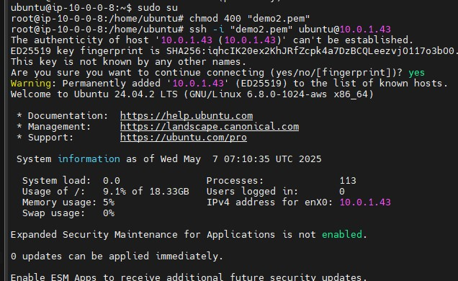
ssh -i <.pem file> username@<private-Ip of tool-server>

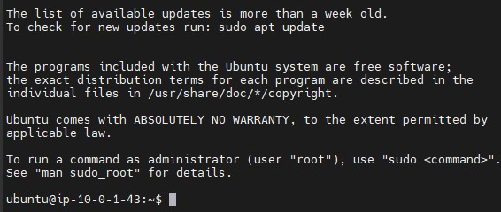

FIG 9
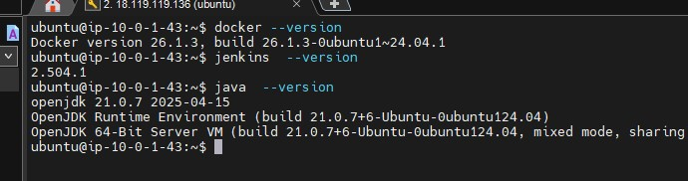
We will be inside of tool-server
install Jenkins, Docker, trivy and SonarQube.

FIG 10
To access Jenkins and sonarqube from internet
Use nginx server reverse-proxy method
Create a sonarqube container using below command
1. docker run -d --name sonarqube -p 9000:9000 -e SONAR_WEB_CONTEXT=/sonarqube sonarqube
Because we trying access soanrqube using path <public-Ip>/sonarqube
Install Nginx server in Jump-server and configure nginx
1. sudo apt update
2. sudo apt install nginx -y
3. cd /etc/nginx/conf.d
Inside conf.d create file with .conf file
<proxy.conf>
1. server {
2. listen 80;
3. server_name 18.222.108.67; ## publicIp of bastion host
4.
5. location / {
6. proxy_pass http://10.0.1.43:8080; # <private-Ip>:8080 for jenkins
7. proxy_set_header Host $host;
8. proxy_set_header X-Real-IP $remote_addr;
9. proxy_set_header X-Forwarded-For $proxy_add_x_forwarded_for;
10. proxy_set_header X-Forwarded-Proto $scheme;
11. rewrite ^/jenkins(/.*)$ $1 break;
12. }
13.
14. location /sonarqube/ {
15. proxy_pass http://10.0.1.43:9000/; # <private-Ip>:9000 for sonarqube
16. proxy_set_header Host $host;
17. proxy_set_header X-Real-IP $remote_addr;
18. proxy_set_header X-Forwarded-For $proxy_add_x_forwarded_for;
19. proxy_set_header X-Forwarded-Proto $scheme;
20. rewrite ^/sonarqube(/.*)$ /sonarqube$1 break;
21. }
22. }
23.

Jenkins server will access from <public-Ip> of bastion host
Sonarqube will be accessed by <public-ip>/sonarqube (bastion-host public-Ip)
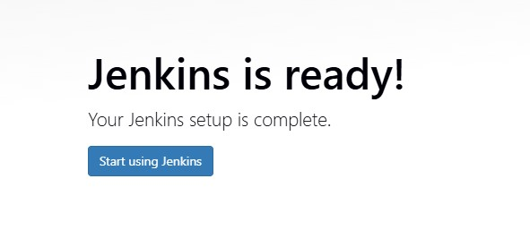

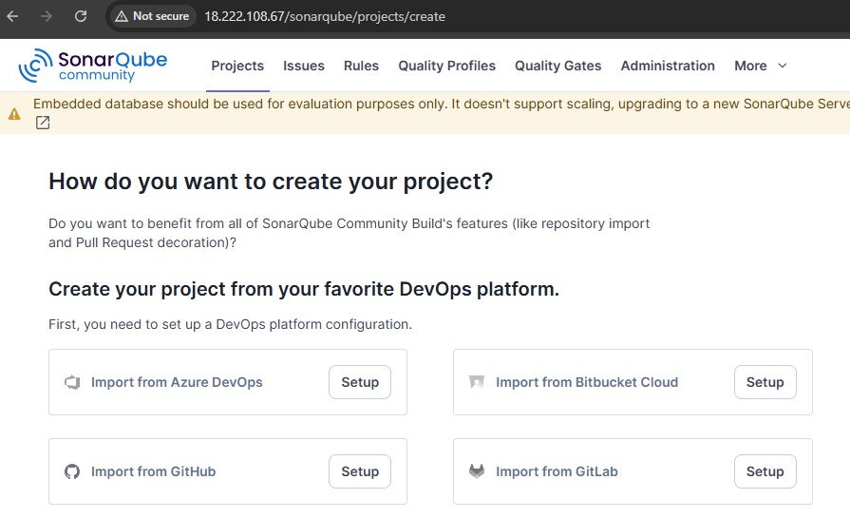
FIG 11

FIG 12

Configure instance for k8s cluster in private subnet
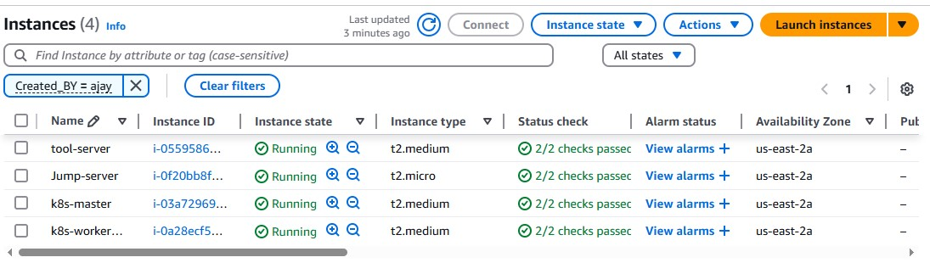

FIG 13
Now access into this k8s instance via baston host
ssh -i <.pemfile> ubuntu@<private-ip of k8s master>
in the same access k8s-worker node
and install k8s
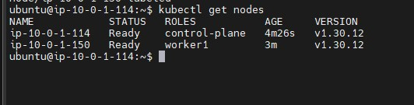

FIG 14

Jenkins CI/CD

Integrating k8s as Jenkins Node.
Access Jenkins using public-Ip bastion host
<public-Ip>

Configure plugins
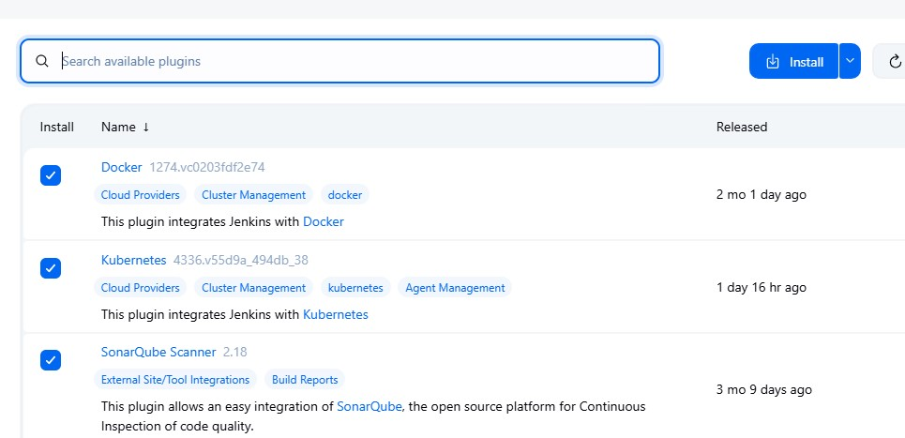

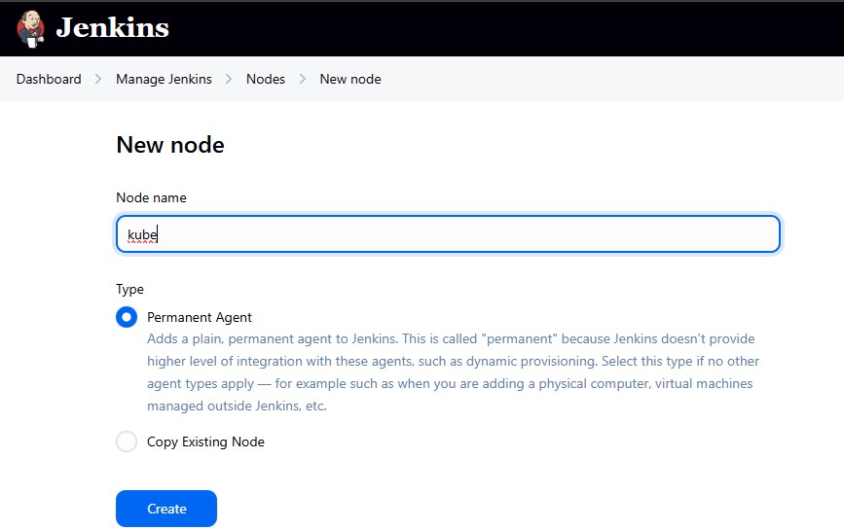
manage Jenkinsnodes give node name permanent agentcreate

FIG 16
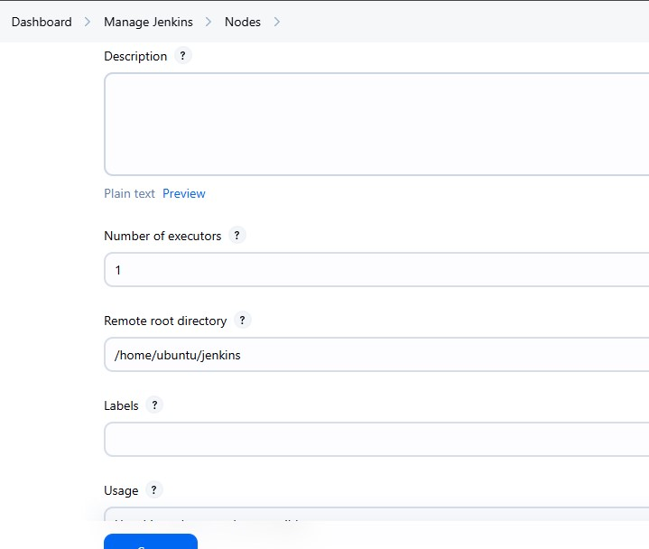
Follow next steps

FIG 17

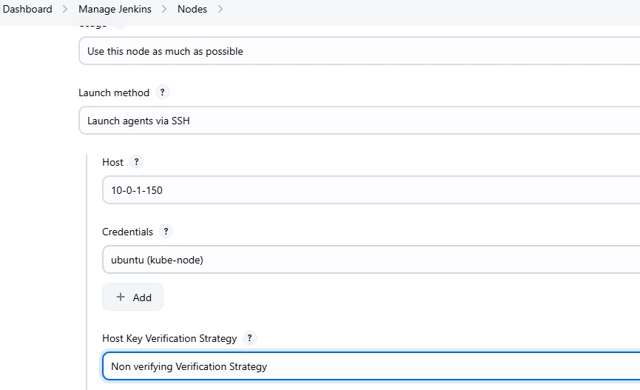

FIG 18
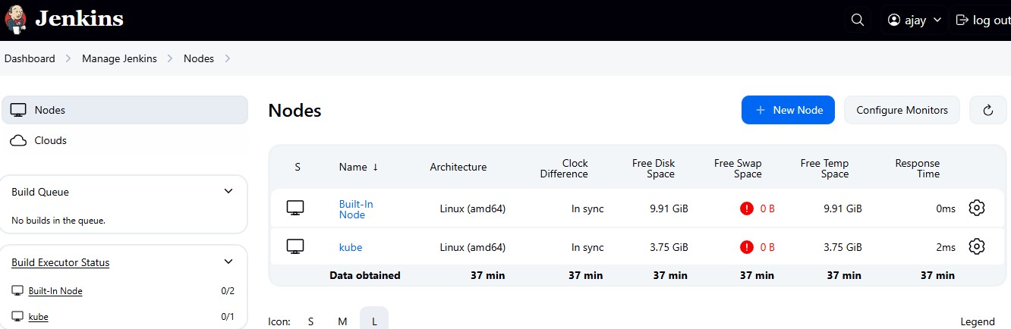
Create

FIG 19

Integrating Docker with Jenkins
Save dockerhub user and password in Jenkins using credentials
manage jenkinscredentialsusername and password
Save it .

Integrating jenkins sonarqube
Access sonarqube using <public-Ip>/sonarqube
administrationsecurityusertoken and create sonar-token
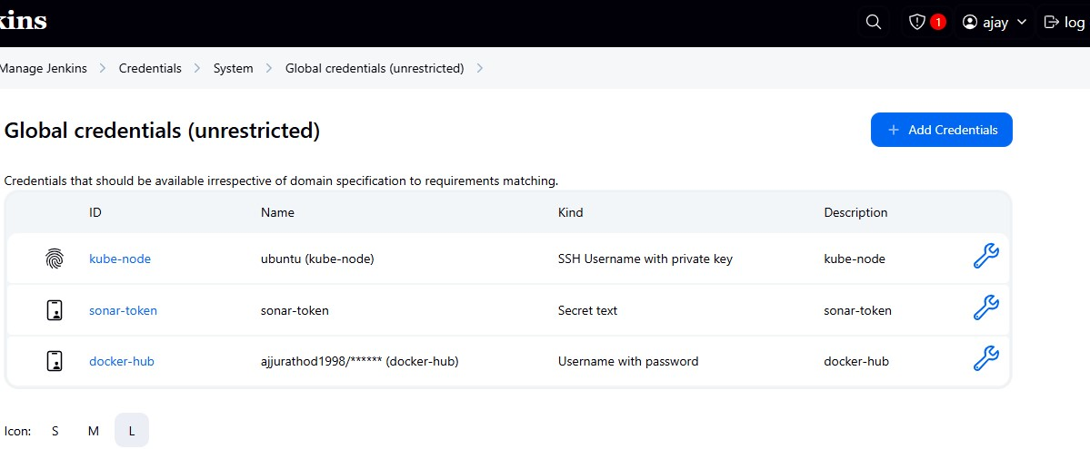
Save them in Jenkins credentials

FIG 20
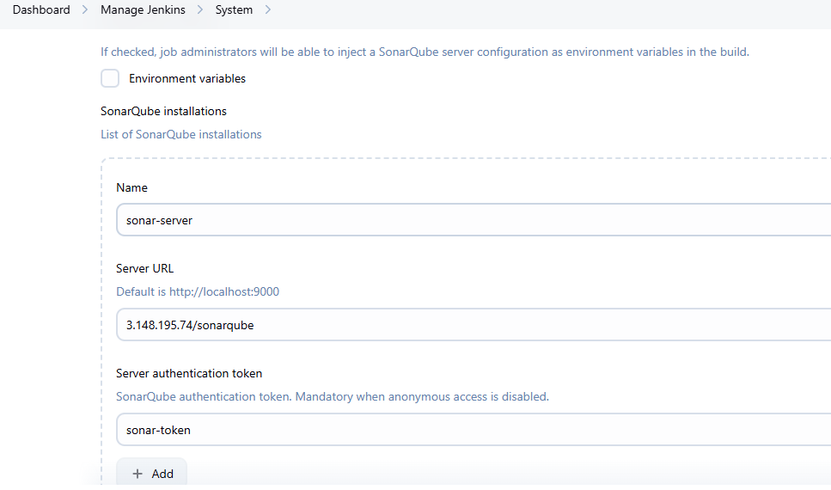
manage Jenkins system sonarqube and add sonar url

FIG 21

To add sonarwebhook
on sonarqube server
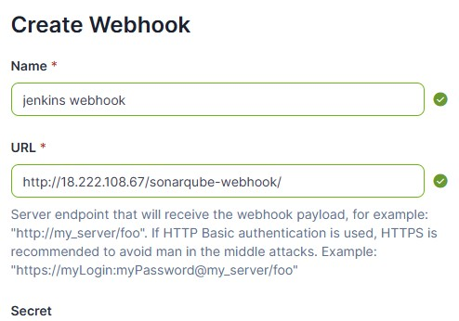
administrationconfigurationwebhook

FIG 22

CI/CD pipeline
This is the Git repo Dotnet application for which CI/CD pipelines needs to build
https://github.com/ajjurathod/dotnet-core-hello-world.git

Dockerfile for dotnet application
1. FROM mcr.microsoft.com/dotnet/sdk:8.0
2. WORKDIR /app
3.
4. # Copy project files and build
5. COPY . ./
6. RUN dotnet publish -c Release -o out
7.
8. # Set working directory and run the app
9. WORKDIR /app/out
10. ENV ASPNETCORE_URLS=http://0.0.0.0:5000
11. ENTRYPOINT ["dotnet", "dotnet-core-hello-world.dll"]

Deployment.yaml file
1. apiVersion: apps/v1
2. kind: Deployment
3. metadata:
4. name: core-dotnet-deploy
5. labels:
6. app: my-dotnet
7. spec:
8. replicas: 2
9. selector:
10. matchLabels:
11. app: my-dotnet
12. template:
13. metadata:
14. labels:
15. app: my-dotnet
16. spec:
17. containers:
18. - name: core-dotnet-cont
19. image: ajjurathod1998/dotnet-core:v1.0.0
20. ports:
21. - containerPort: 5000
22. env:
23. - name: ASPNETCORE_URLS
24. value: "http://0.0.0.0:5000"

Service.yaml
1. apiVersion: v1
2. kind: Service
3. metadata:
4. name: core-dotnet-service
5. spec:
6. selector:
7. app: my-dotnet
8. ports:
9. - protocol: TCP
10. port: 80
11. targetPort: 5000
12. type: NodePort

Jenkinsfile
1. pipeline {
2. agent { label 'kube' }
3. environment {
4. SONAR_AUTH_TOKEN = credentials('sonar-token')
5. }
6. stages {
7. stage('Code Checkout') {
8. steps {
9. git branch: 'master', url: 'https://github.com/ajjurathod/dotnet-core-hello-world.git'
10. }
11. }
12.
13. stage('Source Code Analysis') {
14. steps {
15. withSonarQubeEnv('sonar-server') {
16. sh '''
17. sonar-scanner \
18. -Dsonar.projectKey=dotnet \
19. -Dsonar.sources=. \
20. -Dsonar.host.url=http://3.148.195.74/sonarqube \
21. -Dsonar.login=$SONAR_AUTH_TOKEN
22. '''
23. }
24. }
25. }
26.
27. stage('build docker image'){
28. steps{
29. sh " docker build -t ajjurathod1998/dotnet-core:v1.0.0 ."
30. }
31. }
32. stage('image scanning with trivy'){
33. steps{
34. sh "trivy image ajjurathod1998/dotnet-core:v1.0.0 "
35. }
36. }
37.
38.
39. stage('pushing image to dockerhub'){
40. steps{
41. withCredentials([usernamePassword(credentialsId: 'docker-hub', passwordVariable: 'passwordVariable', usernameVariable: 'usernameVariable')]) {
42. sh "echo $passwordVariable | docker login -u $usernameVariable --password-stdin"
43. sh "docker push ajjurathod1998/dotnet-core:v1.0.0 "
44. }
45. }
46. }
47. stage('deploying the application'){
48. steps{
49. sh "kubectl apply -f deployment.yaml"
50. sh "kubectl apply -f service.yaml"
51. }
52. }
53.
54. }
55. }

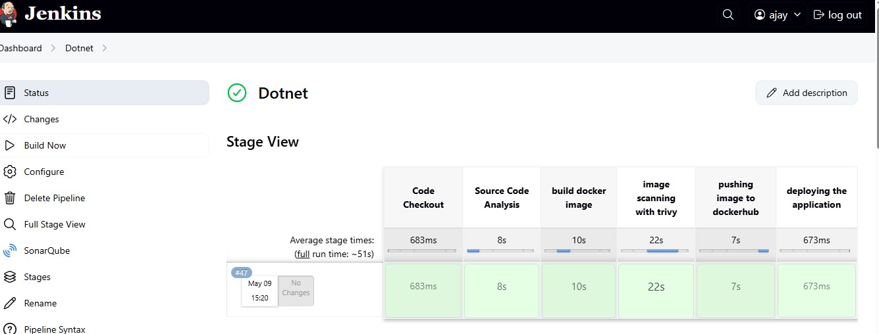
Create a pipeline and run the pipeline

FIG 23

SonarQube analysis.
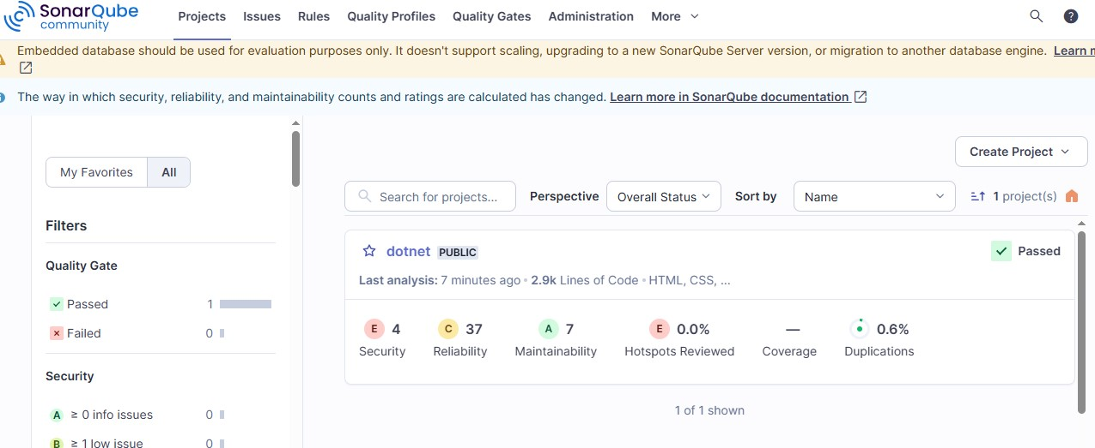

FIG 24
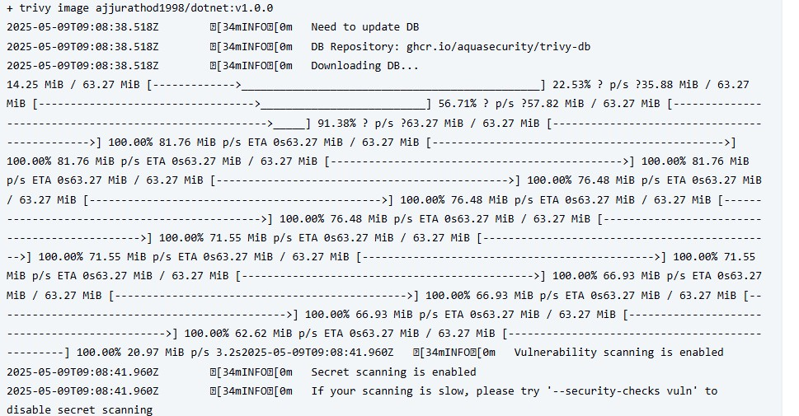
Trivy image scanning

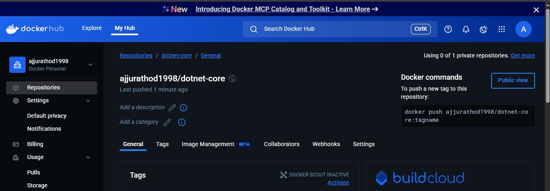
Docker image builded and pushed to dockerhub

FIG 25

Create target group and Load balancer.
On Ec2 console target group instance

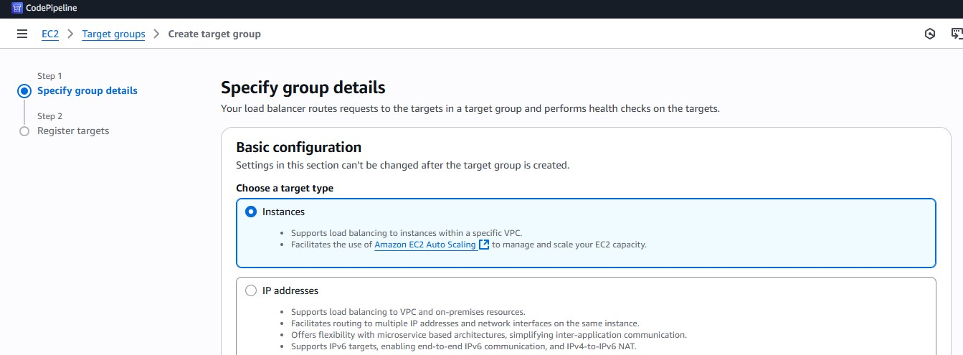

FIG 25
Mention the Port number where your application is running
The application was running at NodePort on worker node
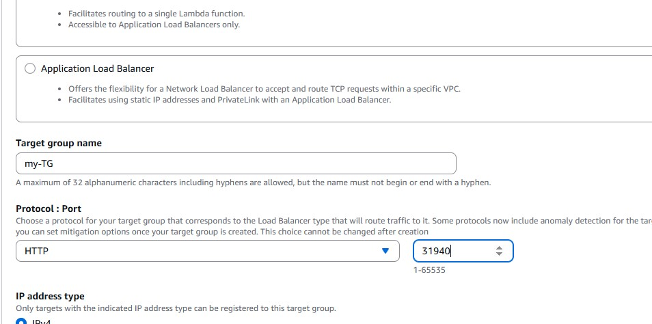
FIG 26
Choose instance where the application is running
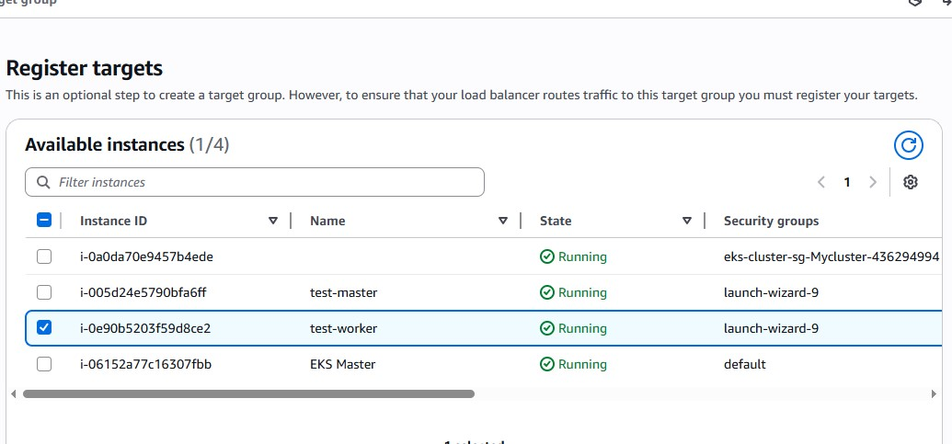
FIG 27
create
Now create Load balaner and attach this Target Group to load labancer
load balanerApplication Load balancer
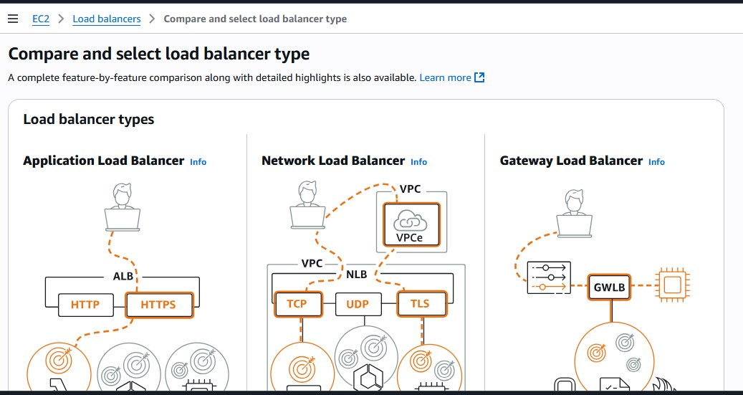
FIG 28

Internet facing
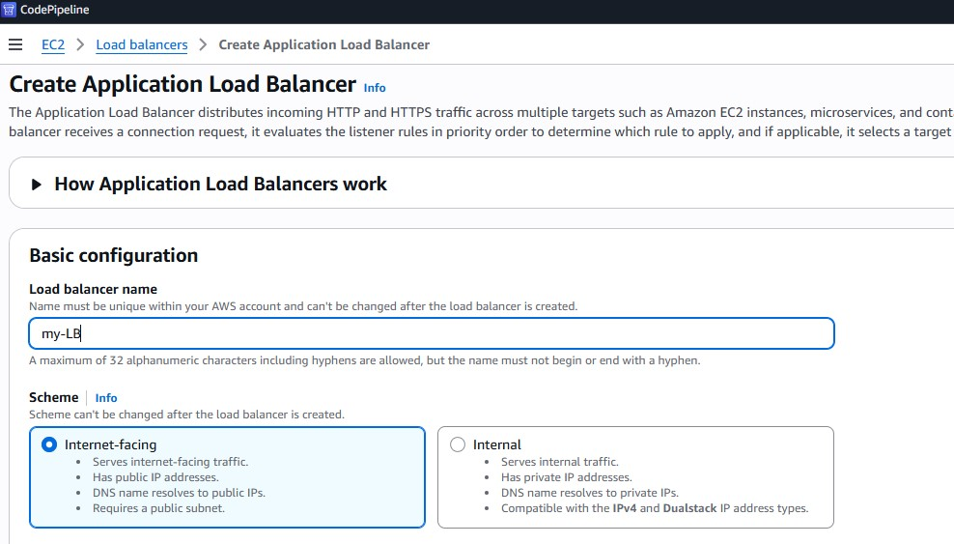
FIG 29
Create security Group which allows port 31940
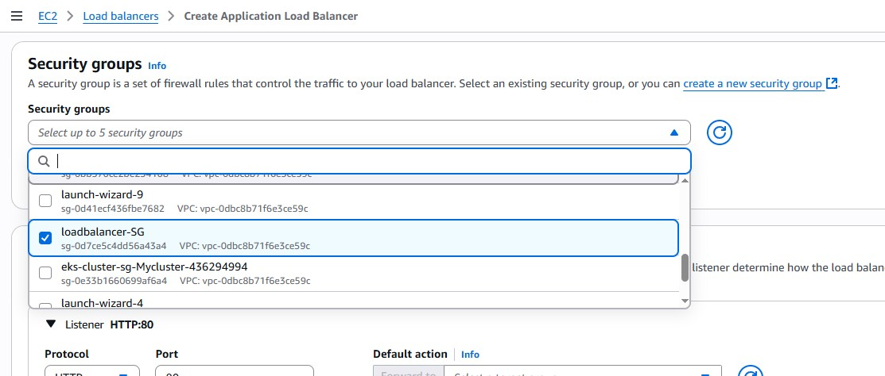
FIG 30

Choose target Group
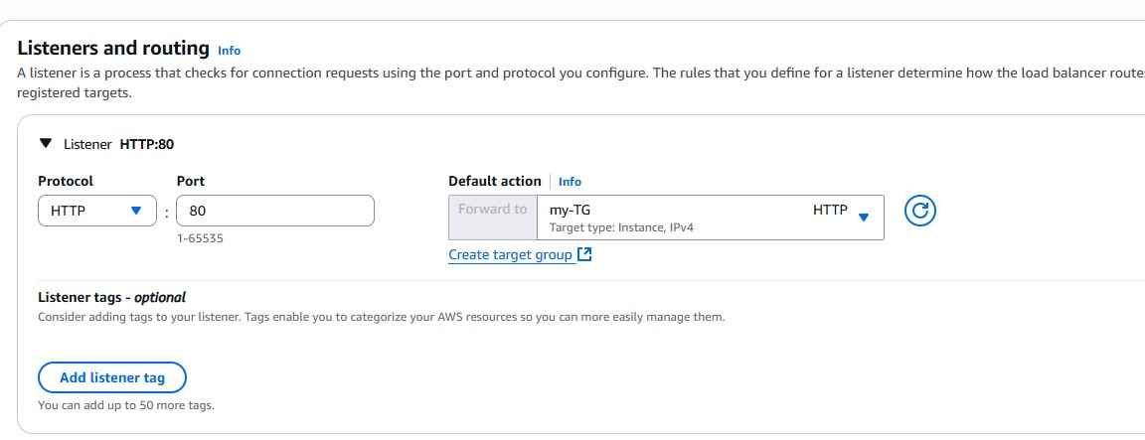
FIG 31
create
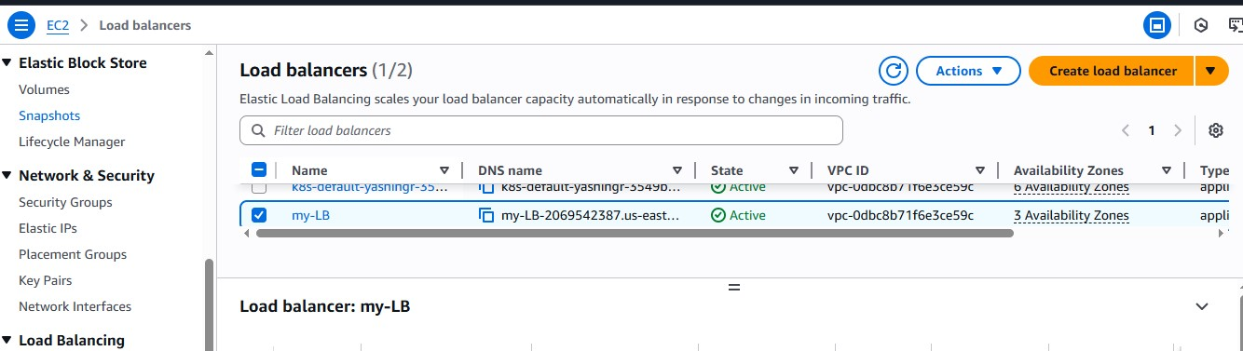
FIG 32
Copy DNS URL of load balancer and browse it
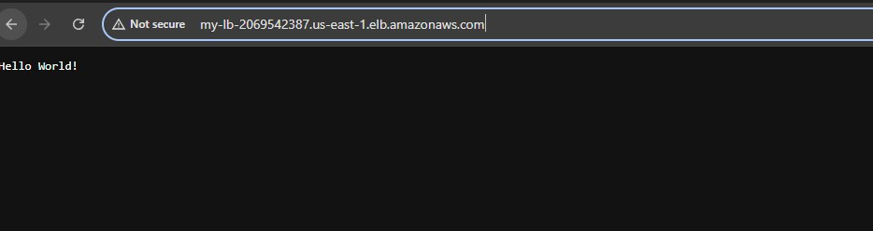
FIG 33

Configure ASG.
Launch new instance and install following commands into it
#!/bin/bash
#!/bin/bash
1. set -e
2.
3. # Disable swap
4. swapoff -a
5. sed -i '/ swap / s/^/#/' /etc/fstab
6.
7. # Update packages and install dependencies
8. apt-get update && apt-get install -y apt-transport-https ca-certificates curl gnupg lsb-release
9.
10. # Add Kubernetes APT repository (Updated)
11. curl -fsSL https://pkgs.k8s.io/core:/stable:/v1.30/deb/Release.key | gpg --dearmor -o /etc/apt/trusted.gpg.d/kubernetes-archive-keyring.gpg
12.
13. echo "deb [signed-by=/etc/apt/trusted.gpg.d/kubernetes-archive-keyring.gpg] https://pkgs.k8s.io/core:/stable:/v1.30/deb/ /" | tee /etc/apt/sources.list.d/kubernetes.list
14.
15. # Install Kubernetes tools
16. apt-get update
17. apt-get install -y kubelet kubeadm kubectl containerd
18. apt-mark hold kubelet kubeadm kubectl

After installing above commads create a image of new instance
new instanceactionimagecreate image
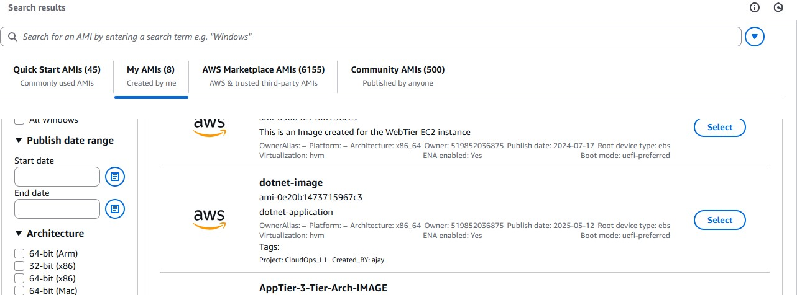
FIG 35
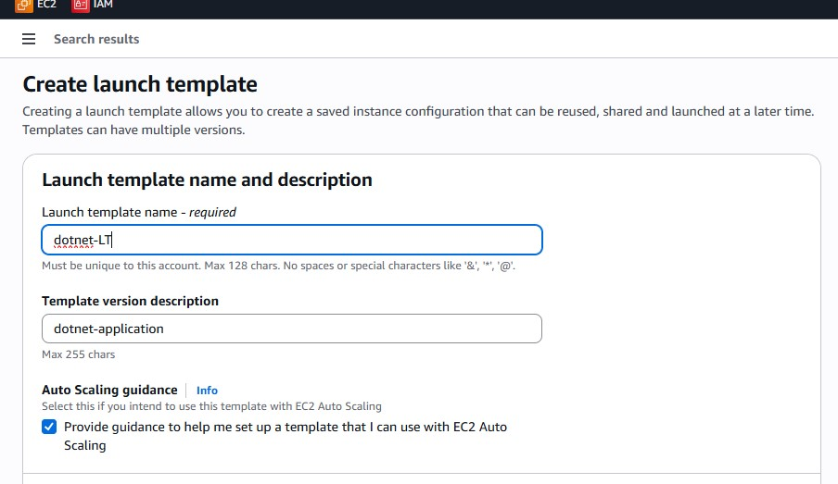
Create launch template using this above images

While creating launch template use this commands in userdata .this will automatically add new ASG instance into kubernetes central plane

#!/bin/bash
1. # Turn off swap (required by Kubernetes)
2. swapoff -a
3. sed -i '/ swap / s/^/#/' /etc/fstab
4.
5. # Enable br_netfilter module for Flannel to work
6. modprobe br_netfilter
7. echo "br_netfilter" > /etc/modules-load.d/br_netfilter.conf
8.
9. # Enable IP forwarding and netfilter on bridges
10. cat <<EOF | tee /etc/sysctl.d/k8s.conf
11. net.bridge.bridge-nf-call-iptables = 1
12. net.ipv4.ip_forward = 1
13. EOF
14.
15. # Apply sysctl params
16. sysctl --system
17.
18. # Reset any previous kubeadm state
19. kubeadm reset -f
20. rm -rf /etc/cni/net.d/*
21. rm -rf /run/flannel
22.
23. # Wait a moment for cleanup to settle
24. sleep 5
25.
26. # Join the Kubernetes cluster (replace with your actual join command if different)
27. kubeadm join 10.0.1.21:6443 --token 0qj0k3.b401xz0ujhe9biya \
28. --discovery-token-ca-cert-hash sha256:34dbc47016263bbb1941d0c3c33d4a03f5f5c21a299e9c763ce9034a9f69a970 \
29. --v=5
30.

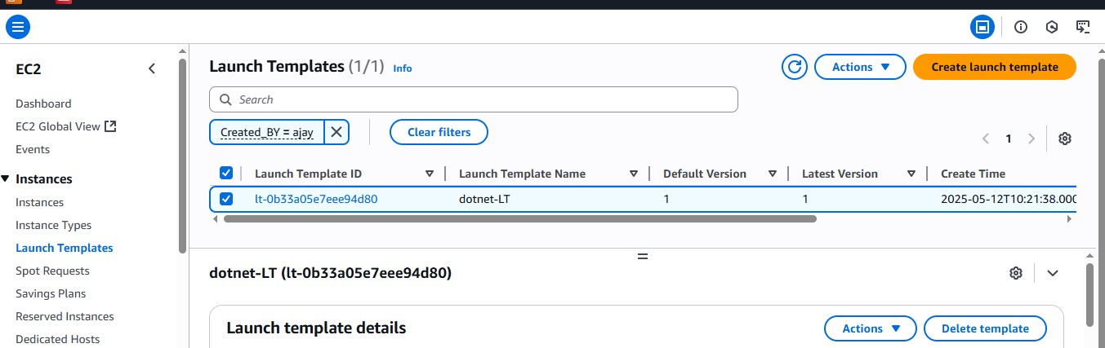
FIG 37

Creates Auto-Scaling-Group
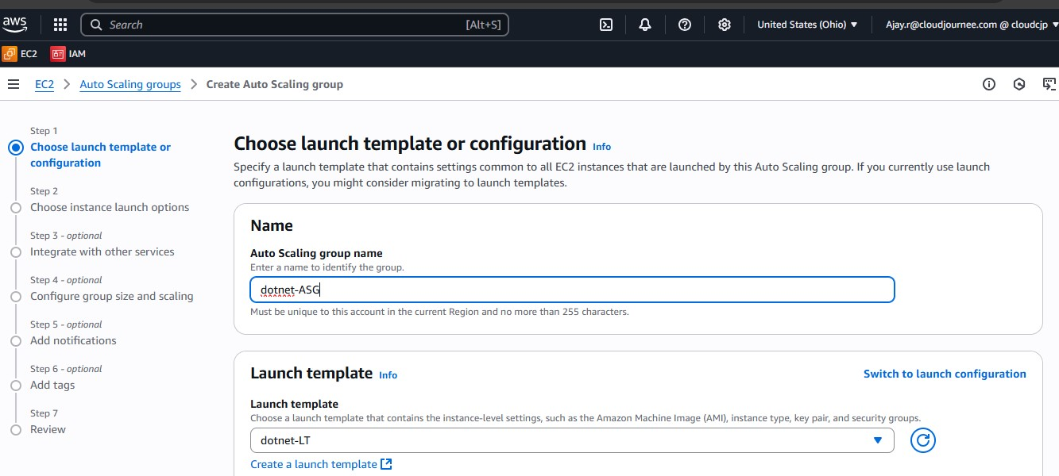

FIG 38

Choose 2 vpc and private subnets of 2 AZ
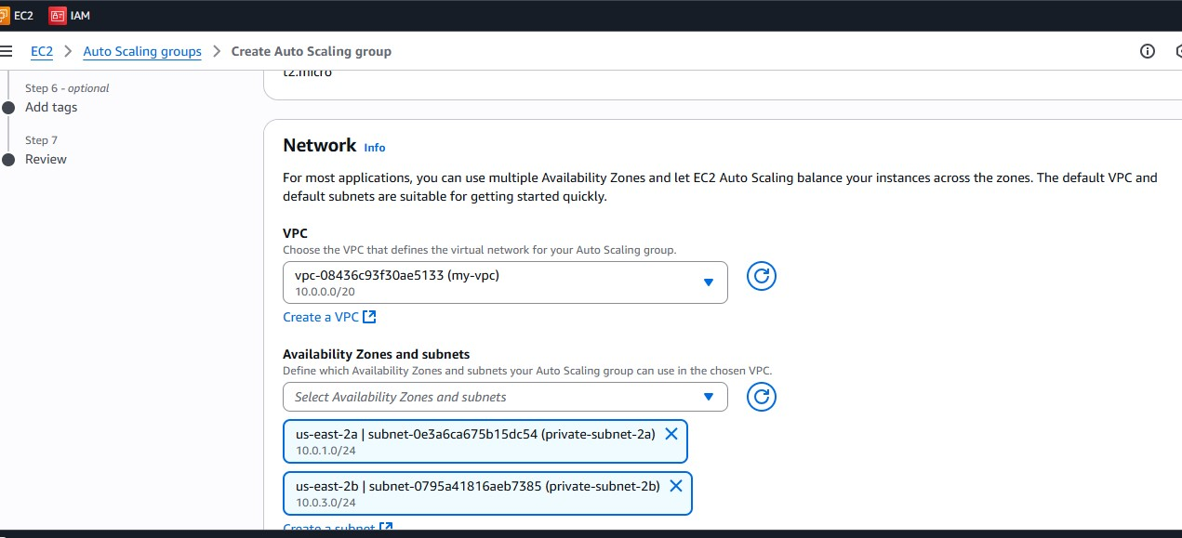

FIG 39
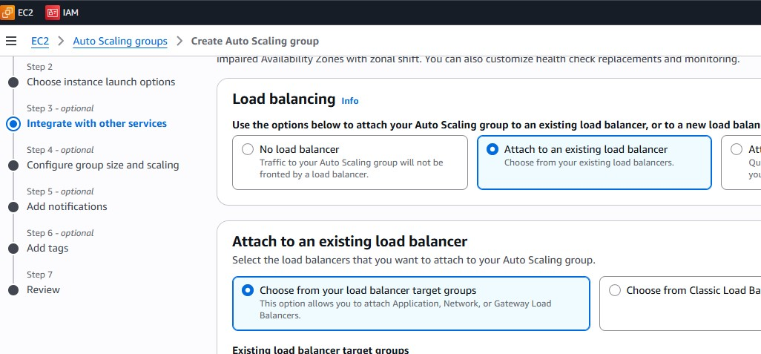
Choose existin load balancer.

FIG 40
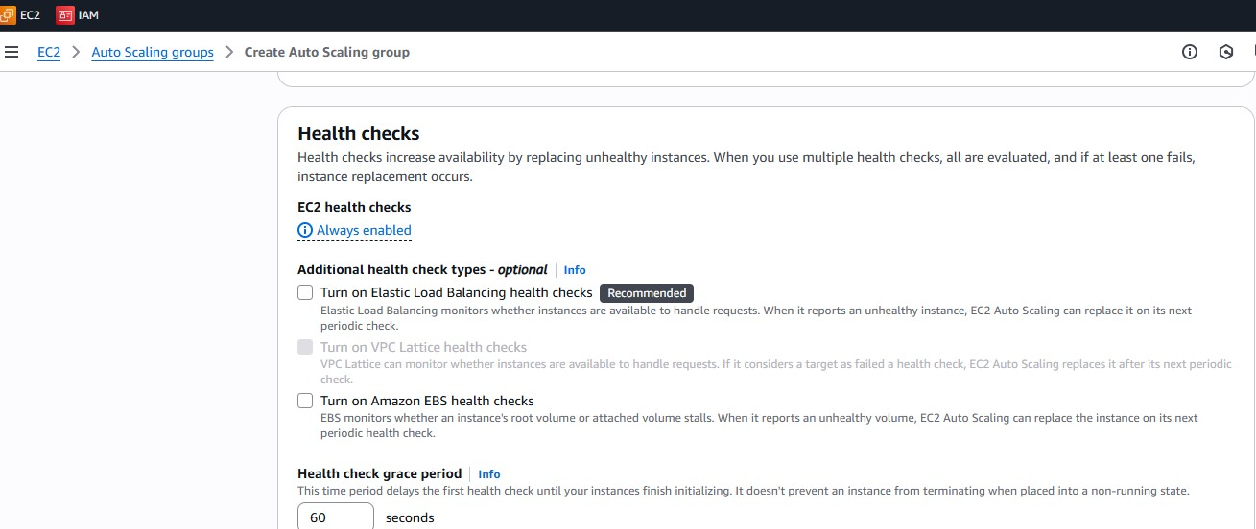

FIG 41

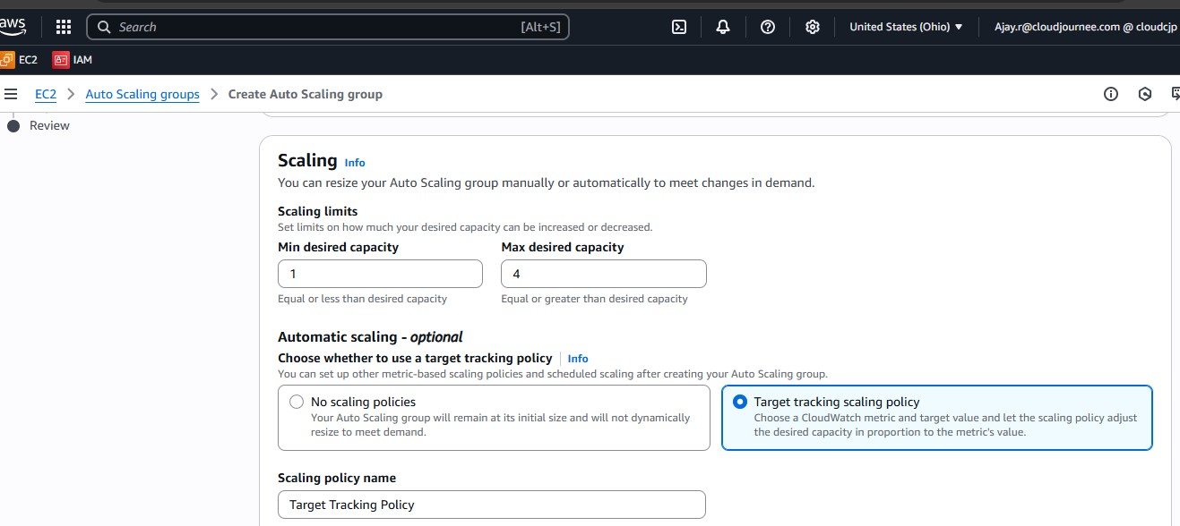

FIG 43
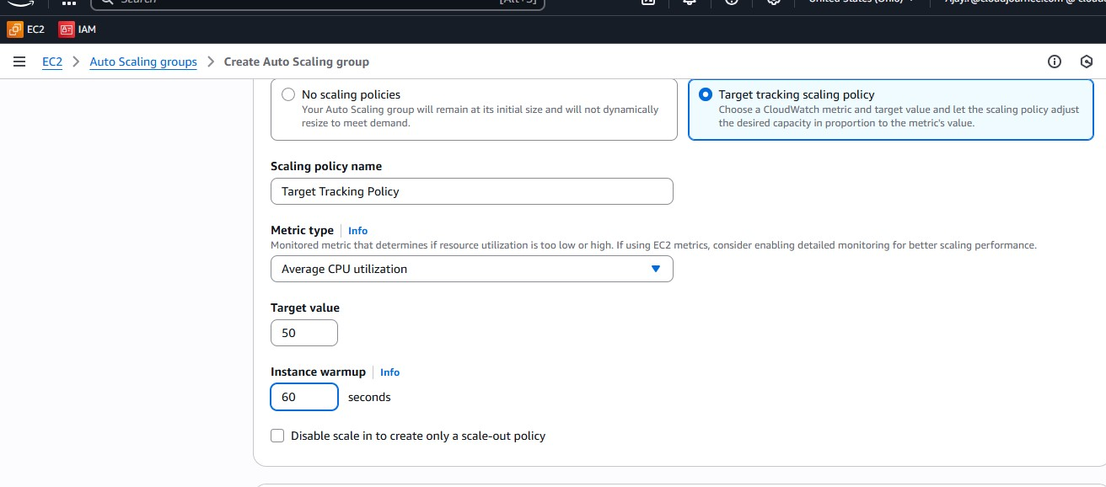

FIG 44
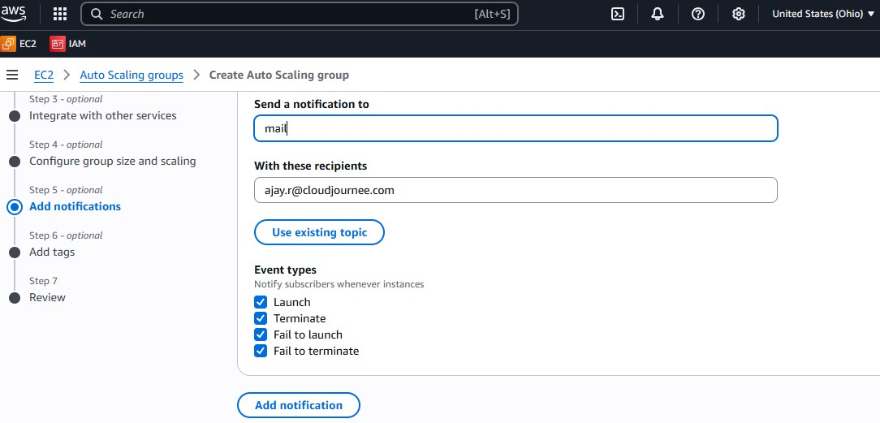
FIG 45

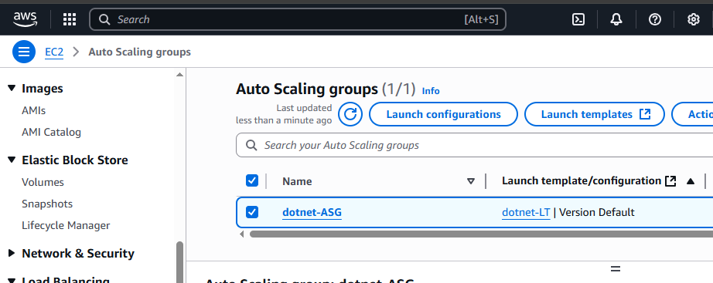

FIG 46
Check mail and subscribe
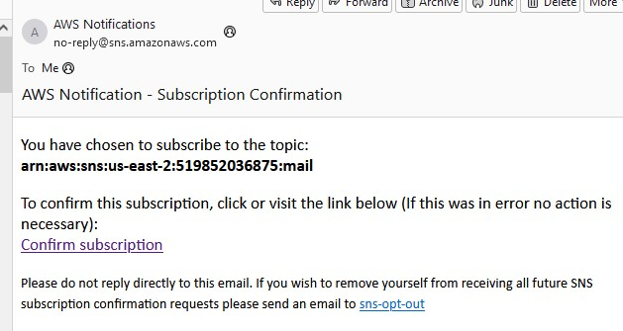

FIG 47
Now check instances for new ASG
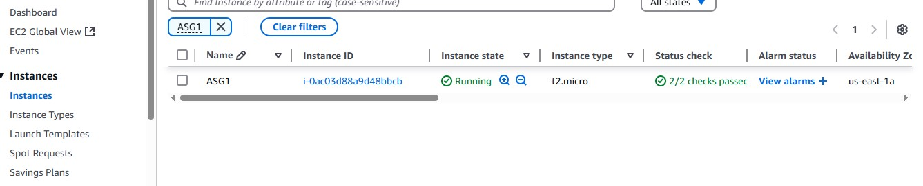
FIG 48

Check the target group new ASG will be updates as a targets
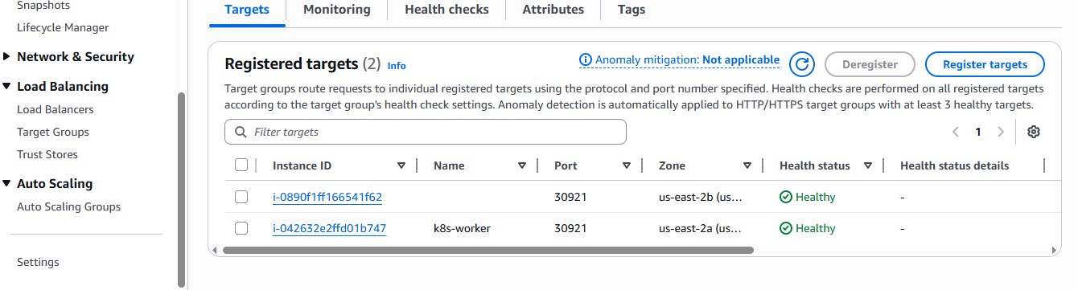

FIG 49
Now copy the DNS url of load balancer and browse
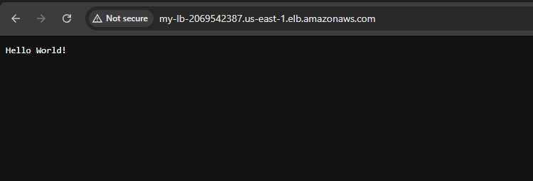
FIG 50
End of Project

10.Providing High Availibity to tool sever which is private subnet
Install aws cli in bastion host
Attach ec2 describe IAM policy to bastion host
Steps:
- Create image of tool-server
- And create instance using same image in different avaibilty zone
- Use a script so that it automatically update private Ip of new instance in nginx reverse proxy server
- Create cronjob so that it will run the job to update newly created tool-server Private-Ip ( based on tag given to instance)

Remember to use the tag in script by which new instance is created
Update the tag
Use this below script in bastion Host (jump server)
sudo cat /usr/local/bin/update-nginx-ip.sh
1. #!/bin/bash
2.
3. # Set variables
4. TAG_NAME="Jenkins"
5. NGINX_CONFIG="/etc/nginx/conf.d/jenkins.conf"
6. JENKINS_PORT=8080
7. SONARQUBE_PORT=9000
8.
9. # Get the private IP of the latest running instance tagged "Jenkins"
10. PRIVATE_IP=$(aws ec2 describe-instances \
11. --filters "Name=tag:Name,Values=$TAG_NAME" "Name=instance-state-name,Values=running" \
12. --query "Reservations[*].Instances[*].[LaunchTime, PrivateIpAddress]" \
13. --output text | sort | tail -n 1 | awk '{print $2}')
14.
15. # Validate IP
16. if [[ -z "$PRIVATE_IP" ]]; then
17. echo "❌ No running instance found with tag Name=$TAG_NAME"
18. exit 1
19. fi
20.
21. echo "✅ Found Private IP: $PRIVATE_IP"
22.
23. # Update Jenkins proxy_pass
24. sed -i "s|proxy_pass http://[^:]\\+:$JENKINS_PORT;|proxy_pass http://$PRIVATE_IP:$JENKINS_PORT;|" "$NGINX_CONFIG"
25.
26. # Update SonarQube proxy_pass
27. sed -i "s|proxy_pass http://[^:]\\+:$SONARQUBE_PORT/;|proxy_pass http://$PRIVATE_IP:$SONARQUBE_PORT/;|" "$NGINX_CONFIG"
28.
29. # Test and reload NGINX
30. if nginx -t; then
31. sudo systemctl reload nginx
32. echo "✅ NGINX reloaded with new IP: $PRIVATE_IP"
33. else
34. echo "❌ NGINX config test failed. Please check your configuration."
35. fi
36.

Create cronjob (for running every two minutes)
Crontab -e
*/2 * * * * /usr/local/bin/update-nginx-ip.sh

It will run the script at every 2 minutes and see any new instance created with Jenkins and try to update its private Ip in nginx proxy

Now stop or terminate old instance and create new instane with Jenkins tag
New instance private IP will be automatically updated

